# 

**(Online Library Management System)**



**Project Team Members:**

1. **VVS.YASWANTH (Team Leader)**
2. **A. NIHARIKA**
3. **DEEPTHI**

# 1.0 DOCUMENT PURPOSE

Online library management system helps students to know the details of available books that are stored in the library through online website. Students can know the details of the books that are available in the library by searching in the required field. The students have the flexibility of preference. They can search the books by the Author name. This project keeps them updated with the news and as well as they can also know the new release of the book of any genre. The online library management helps the students to keep themselves up to date and the website also allows them to view the existing books of their account. It is a system which maintains the information about the books present in the library, their authors, the members of library to whom books are issued. It reduces the workload of management as most of the manual work done is reduced.

This project includes modules such as

1. User Log in and Signup
2. Admin Login
3. View Books
4. Book Inventory
5. Book Issuing Process
6. Issue List
7. Member Details

# 2.0 Module Use case

**2.1 User Log in and Signup**

In User Login and signup module, the User Login page is to access the website. If user hasn’t registered, he/she will go to Signup page to create a new account by providing the required detail like,

**User Signup**

* Full Name
* Date of Birth
* Contact Number
* Email-id
* State
* Pin code
* Address
* Member Id
* Password

After creating the account, the user will Login to the webpage using the below textfields.

**User Login**

* LoginId
* Password

**2.2 Admin Login**

Admin can access the website and handle the student data and books data through login. Below text fields are used to login.

* User Id
* Password

**2.3 View Books**

Here, in this module Registered user or unregistered user can access this page and can see the list of book details that are available in the library.

**2.4 Book Inventory**

This module helps the admin to add/update/delete/view books through the below text fields.

* Book ID
* Book Name
* Language
* Author Name
* Publisher Name
* Publisher date
* Genre
* Edition
* Book Cost
* Pages
* Actual Stock
* Current Stock
* Book Description

**2.5 Book Issuing Process**

Admin can issue and return the book with the help of below textfields.

* Book ID
* Book Name
* Member Id
* Member Name
* Start Date
* End Date

**2.6 Issue List**

Admin can be able to view the details of each and every book specifically or by the entire list.

* Specific user list
* Total issued books

**2.7** **Member Details**

Admin can get the student data by his id and can get his data through this text fields.

* Member Id
* Full Name
* Date of Birth
* Contact Number
* Email-id
* State
* Pin code
* Address

# 3.0 Design and Implementation Constraints

**3.1 Database:** The system shall use the MS SQL Server Database, which is open source and free.

**3.2 Operating System:** The Development environment shall be Windows10

**3.3 Web-Based:** The system shall be a Web-based application ASP.Net

**4.0 Define module & Functionality:**

The system functions can be described as follows:

* **User Log in and Signup:** This is the module where the user can login to his existing account if the user is new then by using the signup option, they can create a new account. The Login Module is a portal module that allows users to type a user name and password to log in whereas, the signup module is an action to register for a new account. This module after successful login or sign up, redirects to the web page.
* **Admin Login:** Admin manage and maintain websites, taking into account functionality, appearance, content, and performance. Their main focus is on the technical aspects of web maintenance, such as building servers and troubleshooting, but they also update the more visible parts of the website, tweaking the design or adding new sections. The admin login with the id and password and then verifies each and every aspect of the user like issuing books, author management, book inventory management and admin has all the details of the user.
* **View Books:** In this module both the Registered user and the Unregistered user can view the books which is available in the library. They can view the book id and then the author of the book, genre, language and then the actual stock, availability of stock, the edition of the book and the pages of the book. The description of the book just like the preface is also visible in the view books module.
* **Book Inventory:**. Here in this module the admin can perform the add, update, and delete operations whereas, the admin can modify the book details from time to time. The author of the book, genre, language and then the actual stock, availability of stock, the edition of the book and the pages of the book, the book description each and everything will be modified or updated by the admin. So, that both the Registered user and the Unregistered can view the book details.
* **Book Issuing Process:** The book Issuing module is only accessed by the admin but not by the user. The access is restricted to the user. The admin verifies the user details and then issues the books to the user. The user returns the book to the admin and then the admin updates the details according to the user id. The Issuing process is completely done by the admin.
* **Issue List:** In this the admin will be able to view all the issued records of the books to the user. Whereas, the admin can view it by two things. Firstly, the admin can directly enter the member id of a particular user and check his entire record by using the specific user list and then admin can view the entire issued list of the books by using the total issued books.
* **Member Details:** The admin gets the user details through this member details module. In this module the user gives his entire information like address details, name, id and all these will be viewed by the admin. These details will be clearly verified by the admin.

**5.0 System Analysis**

System analysis is the first and foremost step performed in developing the software to solve a particular problem. In the analysis part, a software developer examines the requirements. Carrying out preliminary investigation identifies these requirements

* Analysis consists of two sub phases:

1. Planning
2. Requirement definition

During planning phase, cost estimates and work schedules will be planned. Requirement definition is a specification that describes the processing environment, the required software functions, performance constraints (Size, Speed, Machine Configuration) and exception handling.

**6.0 Schema Diagram:**

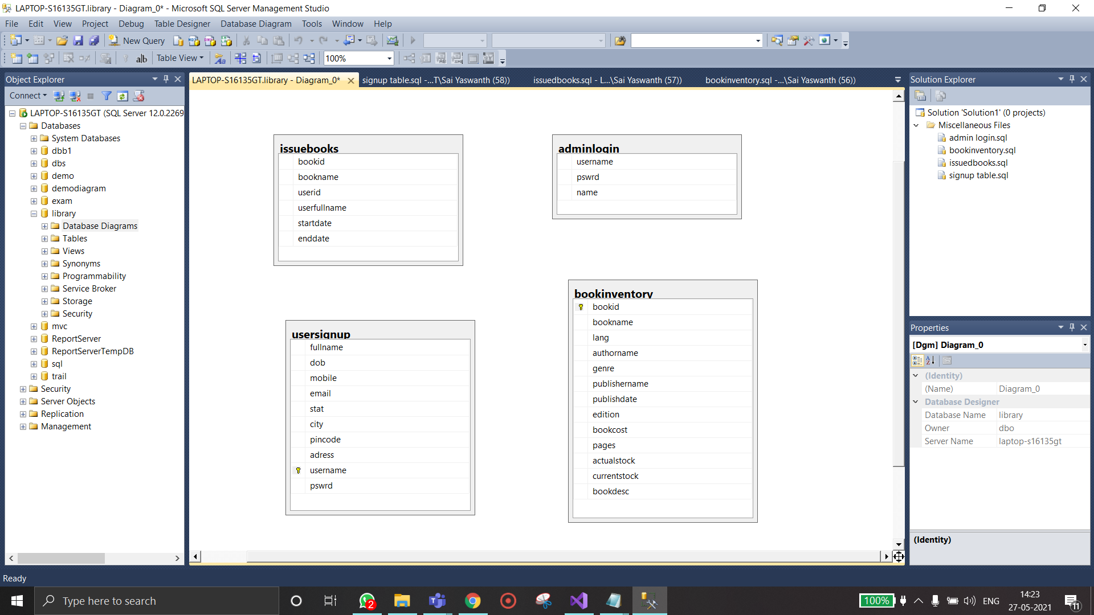

**7.1 Use Case Diagram**

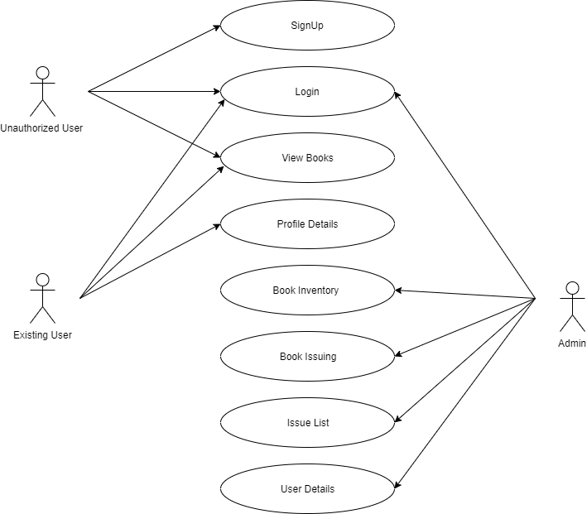

* 1. **Dataflow Diagram**

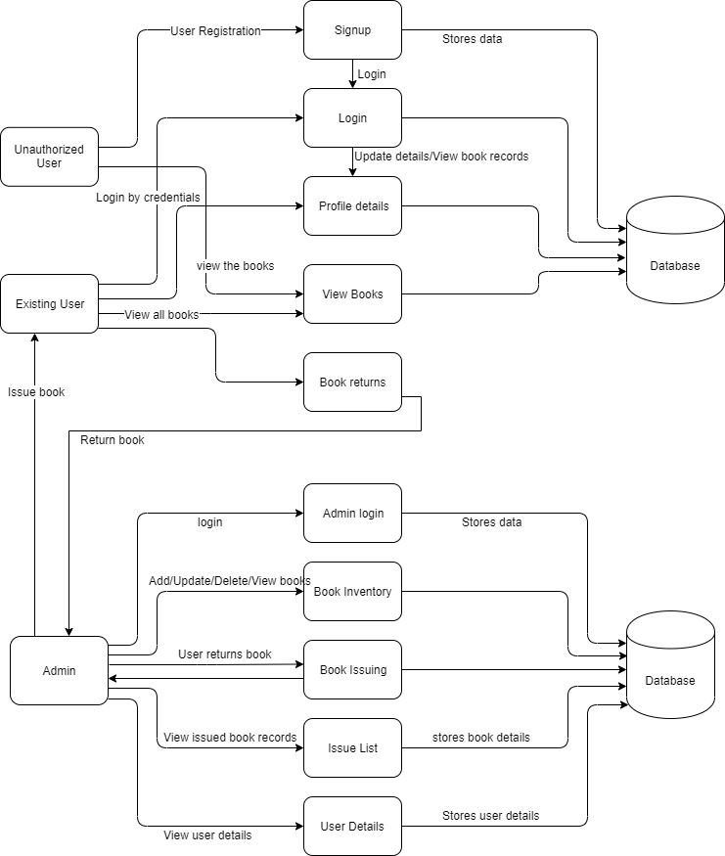

**8.0 Technical:**

1. HTML

2. CSS

3. BOOTSTRAP v4

4. SQL

5.ASP .NET, C#

6. Validation

7. ADO.NET

8. JavaScript

**9.0 Role for Team Members:**

Yaswanth (Team Leader)- asp.net c#, Ado.net, validation

Niharika- Sql database, javascript , Ado.net

Deepthi- Designing

**10.0 Conclusion**

The library management system needs to be computerized to reduce human errors and to increase the efficiency. The proposed library management system in this proposal will be a computerized management system developed to maintain all the daily work of library. Library management systems are designed to store all the information about books and members or users. The main focus of this project is to lessen human effort and encourage efficient record keeping. It helps the user and admin from the manual stress in maintaining the records and gives a track of every detail of the library through online. The main advantage of this project is for the user, where the user can check the books which is present or updated or newly launched whatever the entire information is present in the website. So, that the user can check what is required and also user can view the issued book record of their data.